**Describing graphs - Presentation :vocabulary**

1. Describing Graphs, Tables and Charts
2. What is a chart?
   * A chart is a diagram that makes information easier to understand by showing how two or more sets of data are related.
   * There are two common types of chart, a pie chart and a bar chart.
3. A pie chart is a circle divided into segments . It is usually used to show percentages.
4. A Bar chart is a diagram that makes information easier to understand by showing how two or more sets of data are related. A bar chart is divided into columns .
5. A graph is a diagram , usually a line or curve , which shows how two or more sets of numbers or measurements are related .
6. A table is a set of facts and figures arranged in columns and rows.A table is a very useful way of organising numerical information .
7. What is a trend?
   * Trends are the changes or movements in facts and figures over a period of time.
   * We can use different verbs and nouns to describe trends
8. Downward movement (verbs)
   * decline decrease drop fall slide
   * lose ground
   * crash collapse plummet plunge
   * take a fall
   * weaken
9. Upward movement (verbs)
   * climb rise increase
   * surge
   * rocket
   * soar gain
   * go through the roof
   * jump
   * rally
   * strengthen
10. Stability (verbs)
    * flatten out hold steady level off stabilise
    * bounce back rally recover
11. For specifying the degree of change we can use different adjectives
    * Slow
    * Steady
    * Slight
    * Sharp
    * Gradual
    * Disastrous
    * Massive
    * Perilous
    * Rapid
    * Heavy
    * Nervous
12. Examples
    * Degree of change
    * Speed of change

Pie Charts: Changes in World Population, by Region

The charts show changes in the proportion of world population from different regions in 1900 and 2000.

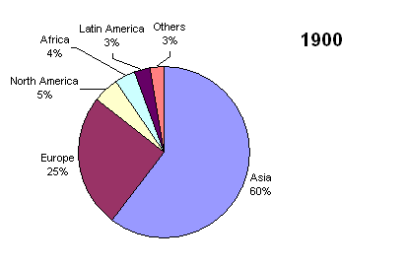

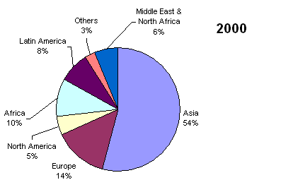

The two graphs show changes in the population of different areas of the world over the last century. Overall, although they still have most of the world’s people, Asia and Europe’s share of the world’s population is decreasing.

The region with the biggest proportion of the world’s population in 1900 was Asia, with 60%. This dropped to 54% in 2000. Europe’s percentage plunged from 25% in 1900 to 14% in 2000. However, the share for all other regions changed dramatically. The percentage of people living in Africa more than doubled from 4.5% to 10%, while Latin America’s proportion almost tripled in the same period. The Middle East and North Africa also increased their share. Only North America’s percentage remained constant.

In conclusion, the percentage of the world’s population living in areas such as Africa and Latin America is growing, while the proportion of people living in Europe and North America is unchanged or falling.